**CURRICULUM VITAE**

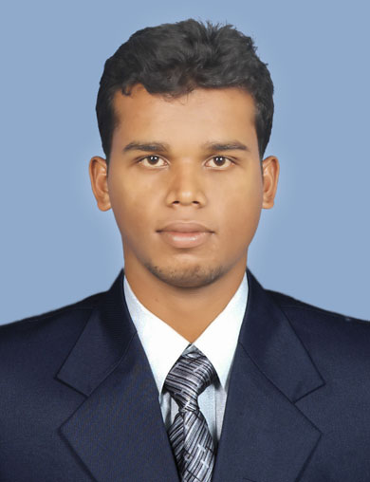

**AMIT KUMAR BISOYI**

**S/o** -Mr. Rama Hari BIsoyi

At - Raghunath Nagar

Po - Aska

Dist-Ganjam, Odisha

Mob-9040582682

E-mail Id:bisoyiamit@outlook.com

**Career Objectives:**

A self motivated person who believes in growth and is very open to new ideas. I am looking for the place where my skill expertise is being fully utilized and proved to be a performing asset to the organization. I am always fascinated towards continuous learning process and capable of working in a team.

**Competencies:**

* Flexibility
* Self Confidence and positive outlook
* Leadership

**Academic Details**:

* **Post Graduation :** PGDM from **Interscience** **Institute of Management and Technology Bhubaneswar.** (2013-15.)

**Area of Specialization : Marketing & Finance**

* **Graduation :** B.scfrom **Anchalika Science college Ganjam**

**Year of passing :** 2013

* **10+2 (Intermediate)** : I.scfrom  **B.S.S Science College Ganjam**

**Year of passing :** 2010

### Summer Internship:

|  |  |
| --- | --- |
| For 3 months | Business Standard .ltd |
| Project Topic | To Study the Market Share Fluctuation of Business Standard News Paper in Customer Prospect at Bhubaneswar Odisha |
| Project Objective | * To identify market share and to know the market penetration of "Business Standard" in various area of Bhubaneswar. * To find out the limitation regarding the customer’s perception towards its brand. |

**Work Experience (if any):**

* Currently Work in Matrix Cellular International Telecom Ltd on The Dept Of Channel Sales .in This Role I have Taken Care of Odisha Zone. And Handled More Then 350 Channel Partner.
* Worked In Snapdeal.com as Business Development Executive From 12.7.2015 Odisha Circle. In this role i have Taken care of 13 zone of odisha. direct meet to sellers and onboard to snapdeal and lunch his products to snapdeal and give training the sellers how to work in snapdeal software And give revenue to the company.
* Worked in Aircel Postpaid Management Service (CSD) From20.5.2014 to27.5.2015 as Customer Relationship Executive (Sales & Service) Bhubaneswar & Berhampur Zone.
* Worked in Dupont Pesticide ltd as a Marketing Development Officer for 4 months in sonpur Dist
* Done project in Business standard Pvt.ltd for 12 weeks.
* Worked in Pantaloons Bhubaneswar to Study the Consumer Behavior and Selling Techniques over there for quite some time.

**Computer Proficiency:**

* Comfortable with MS-Word, MS-Excel, MS-PowerPoint.
* Windows XP/Vista
* Internet

**Extra Curricular Activities / Achievement**

* Participated in NCC (Naval wing) and awarded with ‘A ‘certificate.
* Attended a combined annual training camp and awarded with best ‘CADET’ Award.
* Participated in free health camp and awarded with Best Volunteer Award.

### Interests:

* Social Relation Making
* Playing Cricket
* Net Browsing

### Personal Details:

**Date of Birth : 19th May 1991**

**Name : Amit Kumar Bisoyi**

**Gender : Male**

**Marital Status : Unmarried**

**Languages Known : English, Hindi & Oriya**

**Present Address:**

S/o- Mr.Rama Hari Bisoyi

At- Raghunath Nagar

Po- Aska

Ps- Aska

Dist-Ganjam, Odisha

Pin-761110

**Declaration:**

I do here by declare that all the information mentioned above is true to the best of my knowledge and beliefs and would be responsible if any faulty so found.

**Place**: Bhubaneswar

**Date:**  **Signature**